**TASK 1:**

#include<iostream>

using namespace std;

void swap(int &x,int &y)

{

x = x + y;

y = x - y;

x = x - y;

}

int main()

{

int a, b;

cout << " Number before swapping "<<endl;

cout << "Enter 1st number ";

cin >> a;

cout << "Enter 2nd number ";

cin >> b;

cout << " Number after swapping "<<endl;

swap(a , b);

cout << "Enter 1st number "<<" :"<< a<<endl;

cout << "Enter 1st number " << " :" << b<<endl;

system("pause");

}

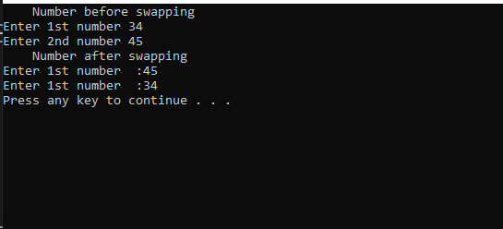

**TASK 2:**

#include<iostream>

using namespace std;

int multiple(int& a, int &b)

{

if (b%a == 0)

return 1;

else if (b%a != 0)

return 0;

}

int main()

{

int a, b,z,c=0,s;

cout << "Enter limit of pair of integers";

cin >> z;

for (int i = 1; i <= z; i++)

{

cout << "Enter first integer :";

cin >> a;

cout << "Enter second integer :";

cin >> b;

cout << multiple(a, b) << endl;

}

system("pause");

}

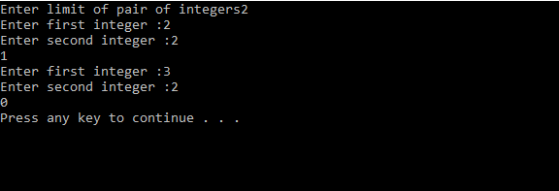

**TASK 3:**

#include<iostream>

using namespace std;

void sorting(char& a, char& b, char&c)

{

       char max=0, mid=0, min=0;

       if (a >= b && a >= c)

             max = a;

       if (a >= b && a <= c)

             mid = a;

       if (a <= b && a <= c)

             min = a;

       if (b >= a && b >= c)

             max = b;

       if (b >= a && b <= c)

             mid = b;

       if (b <= a && b <= c)

             min = b;

       if (c >= a && c >= b)

             max = c;

       if (c >= a && c <= b)

             mid = c;

       if (c <= a && c <= b)

             min = c;

       if (a >= c && a <= b)

             mid = a;

       if (b >= c && b <= a)

             mid = b;

       if (c >= b && c <= a)

             mid = c;

       c = max;

       b = mid;

       a = min;

}

int main()

{

       char a, b, c;

       cout<< "Enter 3 chracters for sorting" <<endl;

       cin>> a >> b >> c;

       sorting(a, b, c);

       cout<< "character after sorting (A to Z)" <<endl<< a <<endl<< b <<endl<< c <<endl;

       system("pause");

}

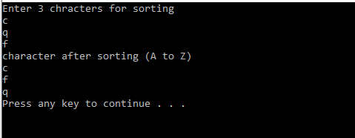

**TASK 4:**

#include<iostream>

using namespace std;

void divisor(int &i, int&j)

{

int d;

for (i = 1; i < 1000; i++)

{

int sum = 0;

for (j = 1; j < i; j++)

{

if (i%j == 0)

{

cout << "The value of i is" << i << " :";

cout << j << endl;

sum += j;

}

}

cout << "sum= " << sum << endl;

if (sum%i == 0)

{

cout << "perfect number" << endl;

}

else

{

cout << "not a perfect number" << endl;

}

}

}

int main()

{

int i, j;

int num;

divisor(i, j);

system("pause");

}

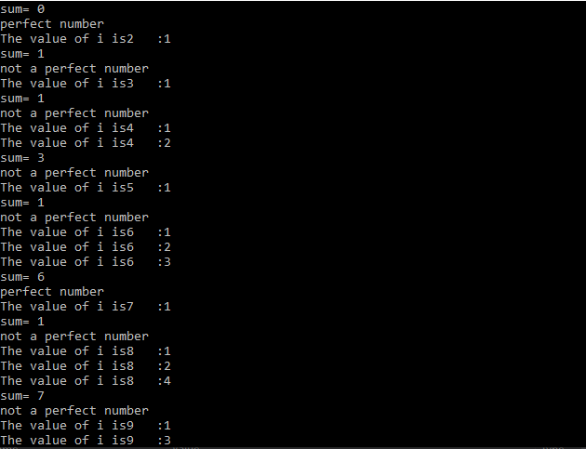

**TASK 5**

#include<iostream>

using namespace std;

void carparking(float &rate, float &hours)

{

int hours_w = 0;

rate = 2;

for (int i = 1; i <= 3; i++)

{

cout << "Enter hours of " << i << " person" << endl;

cin >> hours;

if (hours <= 3)

{

cout << "charges are " << rate << endl;

}

else if (hours > 3 && hours < 24)

{

hours_w = hours - 3;

float charges = 2 + (hours_w*0.5);

cout << "charges are " << charges << endl;

}

else if (hours == 24)

{

cout << "charges are " << 10 << endl;

}

}

}

int main()

{

float rate, hours;

carparking(rate, hours);

system("pause");

}

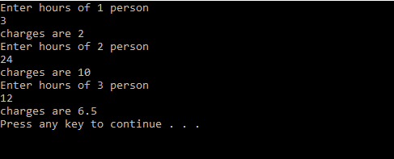

**TASK 6**

#include<iostream>

using namespace std;

void gues(int &gues,int &mynum)

{

int guess, mynum, a = 0;

char choice;

mynum = (rand() % 1000 + 1);

do

{

cout << "I have number between 1 t0 1000" << endl << "Can you guess the number ?" << endl << "Please type your first guess" << endl;

cin >> guess;

if (mynum == guess)

{

cout << "Excellent! You guessed the number! Would you like to play again (y or n)?" << endl;

cin >> choice;

a = static_cast<char>(choice);

if (a == 110)

{

break;

}

mynum = (rand() % 1000 + 1);

}

else if (guess < mynum - 200)

{

cout << "Too low. Try again." << endl;

}

else if (guess > mynum + 200)

{

cout << "Too high. Try again." << endl;

}

} while (a != 110);

}

int main()

{

gues();

system("pause");

}

